Techno-Commercial Offer Document of

Revamping the Camera Web Application

Design & Development And

Annual Maintenance Contract

Submitted To

**IVTECH COMPUTER SYSTEMS LLC**

Version 1.0

22nd November 2024

*Proposal Validity: 25 Days*

**Prepared By:**

**SPEC INDIA**

**Revision History:**

|  |  |  |  |
| --- | --- | --- | --- |
| Date | Doc Version | Author | Created / Updated / Reviewed /  Verified / Approved By |
| 22nd November, 2024 | 1.0 | Mitesh Modi | Created and reviewed |
| 22nd November, 2024 | 1.0 | Yaman Kavishwar | Verified and approved |

Contents

1. Introduction 5

1. Acknowledgement 5

2. Overview of the Document 5

3. Abbreviations / Acronyms 5

2. About SPEC 6

Customer snapshot 6

3. Project Scope 7

1. Purpose 7

2. Functional Requirement Document 7

Dashboard rough design work: 11

Following are the Screenshots for the same: 11

3. Assumptions 14

3.3.1. General 14

3.3.2. Project Specified 14

4. Technology Stack 15

3.4.1. Technology Stack for Web Application Development 15

4. Project Timeline 15

5. Commercials 16

1. Total Effort and Cost Estimation 16

2. Payment Milestones 16

3. Miscellaneous Charges 17

4. Payment Terms & Conditions 17

6. Execution Methodology For AMC 20

7. List of Assumptions / Exclusions & Dependencies 21

8. Project Approach and Methodology (Standard) 22

1. Project Approach 22

8.1.1. Execution Methodology 22

2. Change Management Process and Bug Support 24

8.2.1. Bug Support 24

8.2.2. Change Management Process 24

3. Review Process 25

4. Execution Environments 25

5. Escalation Matrix 25

9. Project Management Methodology at SPEC (Standard) 26

1. Testing and Quality Assurance at SPEC 26

10. Project Deliverables 28

11. Responsibilities of Client and SPEC (Standard) 29

12. Project Team Organization (Standard) 30

13. Risk identification and mitigation plan (Standard) 31

14. SPEC Holiday Calendar 2025 33

15. Signatures 34

# Introduction

## Acknowledgement

SPEC applauds **IVTECH COMPUTER SYSTEMS LLC** for allowing us to submit a Techno-Commercial proposal for **Revamping the existing** **Camera Web Application and developing new features and functionalities.** This proposal **also includes** annual maintenance support for the proposed application after development**.** The tentative start date of the engagement will be **December 20th, 2024.**

## Overview of the Document

This proposal details the proposed scope of work, project execution approach, assumptions, dependencies, and other required details. However, it is possible that requirements are unearthed during the SRS & development phase and requested changes that are not part of the current scope but need to be incorporated into the solution. Such changes and modifications will be jointly discussed for implementation, along with the impact on timelines and commercials.

## Abbreviations / Acronyms

|  |  |
| --- | --- |
| Abbreviations | |
| AMC | Annual Maintenance Contract |
| BRD | Business Requirements Document |
| Client | **IVTECH COMPUTER SYSTEMS LLC** |
| SPEC | SPEC INDIA |
| SOW | Scope of Work |
| DB | Database |
| FOC | Free of Cost |
| BTL | Below the Line |
| NA | Not Applicable |
| BI | Business Intelligence |
| POC | Point of Contact |
| ROI | Return on Investment |
| SDLC | Software Development Life Cycle |
| SIT | System Integration Testing |
| SPOC | Single Point of Contact |
| TAT | Turn Around Time |
| UAT | User Acceptance Testing |
| UI | User Interface |
| V & V | Validation and Verification (Synonym to Quality Assurance) |

# About SPEC

* An ISO 27001: 2022 and 9001:2015 certified Software Solutions company
* 36+ years of experience in delivering business solutions.
* 250+ consultants at the Ahmedabad office
* Marketing office in the USA
* Successfully executed projects across 25+ countries
* Successfully implemented multi-location business-critical solutions for Fortune 100 Corporations
* 36,000 sq. ft. Off-shore Development Center at Ahmedabad, India

## Customer snapshot

The countries where SPEC has executed projects with a brief snapshot of the customers are highlighted below.

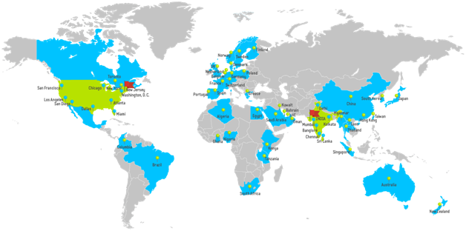

# Project Scope

## Purpose

The purpose of this project is to **revamp** an **existing Web Application** with a dashboard that enables surveillance professionals to make data-driven decisions so that we can revamp the existing web application and develop the new features and functionalities shared by the client in the document “Technical Requirements Doc R2”.

## Functional Requirement Document

The Requirement is present in the “Technical Requirements Doc R2” document shared by **IVTECH COMPUTER SYSTEMS LLC**, which contains information for **Custom Web Application** modules related to the following:

* User Login
  + Users can log in using their credentials.
  + User can reset own password (Forgot password)
  + Change Password
* User Management
  + Add/Update/Delete users.
  + Assign Role - Permissions to Users to access camera/floor/zone/reports
* Camera Management
  + Add/Update/Delete camera.
  + Listing of Cameras with search/filter
* Settings
  + Upload Customer Logo
  + License Management
* Site and Zone Management
  + Add/Update/Delete Site
  + Add/Update/Delete Floor Plan
  + Add/Update/Delete Zone on Floor Plan
  + Add cameras to zones.
  + Camera rotation
  + Map integration with static map images.

**Imp Note**:

* For the Map Integration, the user needs to be online once, maybe while creating the Site to download the map images. Otherwise, we cannot identify which country/region/area images need to be downloaded to make the map work with static images.
* For now, we will go for Open source to achieve the functionality of Offline maps. This is the subject of exclusive R&D; hence the final selection of the open-source solution will be done post R&D and discussion with the client team.
* Cost & Timeline of achieving the Offline Map integration functionality may vary depending on the selection of the solution post R&D. For now, we have considered 80hrs of development for achieving Offline Map integration functionality.
* Dashboard
  + Report Filtering
  + Export to PDF/excel/csv.
  + Camera - No of Camera Installed
  + Camera - No of Camera Online/Offline
  + Camera - Online vs Offline Ratio
  + Camera - No of Camera by Model Type
  + Camera - No of Camera by Feature type
  + Site - Total Capacity
  + Site - Capacity Utilization (%)
  + Site - Most vs. Least Day for Capacity Utilization
  + Site - Zone-wise details for Max Capacity, Utilization, % (Table)
  + People Counting - People In
  + People Counting - People Out
  + People Counting - Avg. People In/Out in Day with Min and Max Count
  + People Counting - Cumulative People Count for Time
  + People Counting - Zone wise.
  + People Counting - Gender-wise.
  + People Counting - People with and without Mask/Helmet
  + People Counting - Most and Least Count Day for Specific Male and Female
  + People Counting - Slip and Fall Count for People with Gender
  + People Counting - New vs Total Visitors
  + Shopping Cart Counting
  + Heatmap for shopping cart
  + Queue events for shopping cart
  + Queue events for people
  + Blocked exit detection
  + Vehicle - Vehicle Count (Min, Max, Avg. per Day)
  + Vehicle - Vehicle by Type
  + Vehicle - Vehicle In/Out
  + Vehicle - Vehicle in Wrong Direction
  + Vehicle - Stopped Vehicle Count Time
  + Vehicle - Speed Detection by Vehicle
  + Vehicle - Avg. Speed for Vehicle
  + Vehicle - Traffic Jam by Day
  + Vehicle - Day-wise Traffic (Most and Least)
  + Vehicle - Speed Violation by Vehicle
  + Vehicle - Vehicle U Turn detection
  + Vehicle - Pedestrian detection
  + Vehicle - Vehicle Turning Movement counts
  + Vehicle - Vehicle Queue Analysis
  + Vehicle - Vehicle Detection Heatmap
  + Detect Forklifts
  + Proximity detection (between people, forklifts, between a person and a forklift)
  + Forklift speed detection
  + Counting & Heatmap for forklift and people
  + Queue events for forklift and people
  + Blocked exit detection
* The list of dashboard widgets specified above includes existing APIs related to Crowd Management, Queue Management, Traffic (Vehicle), Retail, and Factory AI Pack.
* Package creation
  + Create a package to install the web application on any Windows PC.
* Data Ingestion
  + Scheduled calling of Camera APIs to ingest data in the database.
* Camera API Understanding and Integration
  + Solar Power and Battery Utilization details will be shown on the dashboard through SNMP/API integration with the BMS and MPTT Controller (calling of camera API and just displaying the data available from API).
* Configuration
  + Standard Backup and Restore
* AI Box Integration
  + AI Box integration, considering the addition of multiple cameras in a single AI Box and considering the cameras added in the AI Box to display Dashboard widgets data.
* Alexa Integration
  + Integration with Alexa, so that when the Alexa device is connected, it will open the specific widget on voice command
* Other 7 key features:
  + Provide data for multiple lanes (8 lanes).
  + Show heat maps on the floor plans and particular zones.
  + Multisite-wise dashboard widget reports.
  + For Multisite should be filtered to select the widgets and show the difference between Full site, single-zone, and Multizone.
  + SSL / HTTPS set up.
  + Need to have Event reporting details with filtration with separate widgets or separate pages for this, and when the event is reported, need to have pre- and post-video of 5 seconds each.
  + Need to have SMTP setup for email reporting. With schedule.
* **Admin User Login**
  + Admin users can log in using their credentials.
  + User Management
* **Customer Management (Separate application)**
  + Customer Details
  + Customer Licensing details, generating licenses, and sending emails to respective addresses.

### 

### Dashboard rough design work:

To get an idea of what we are planning to have in the new design for the dashboard, please review this link: <https://www.figma.com/proto/kCzHatA3xMTWMuofs2LJz4R2/VISION-INSIGHT?node-id=156-2362&scaling=scale-down-width&content-scaling=fixed&hide-ui=1&t=48dFjD9GANscLeFo-8>

### Following are the Screenshots for the same:

**#1. Dashboard:**

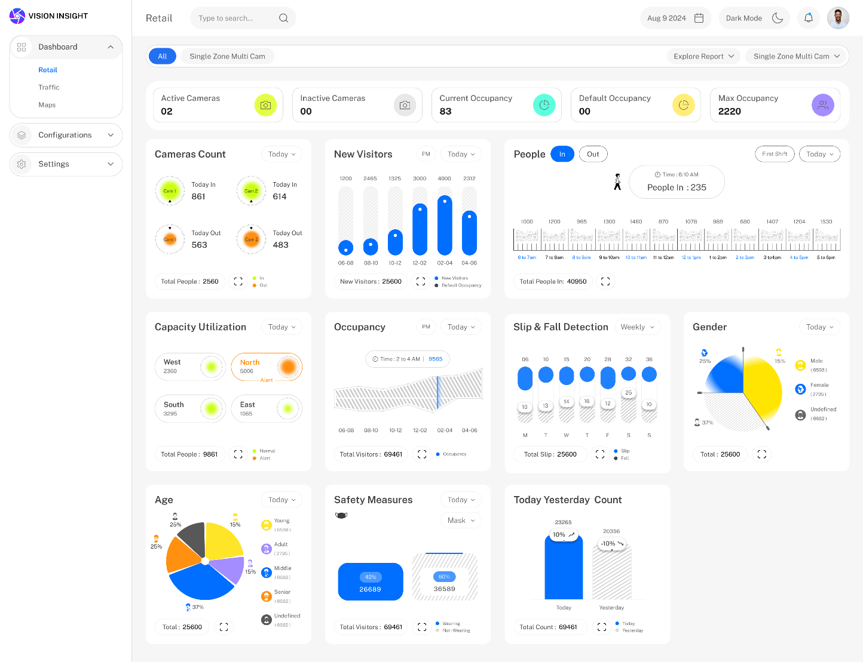

**#2. Dashboard (in Dark Mode):**

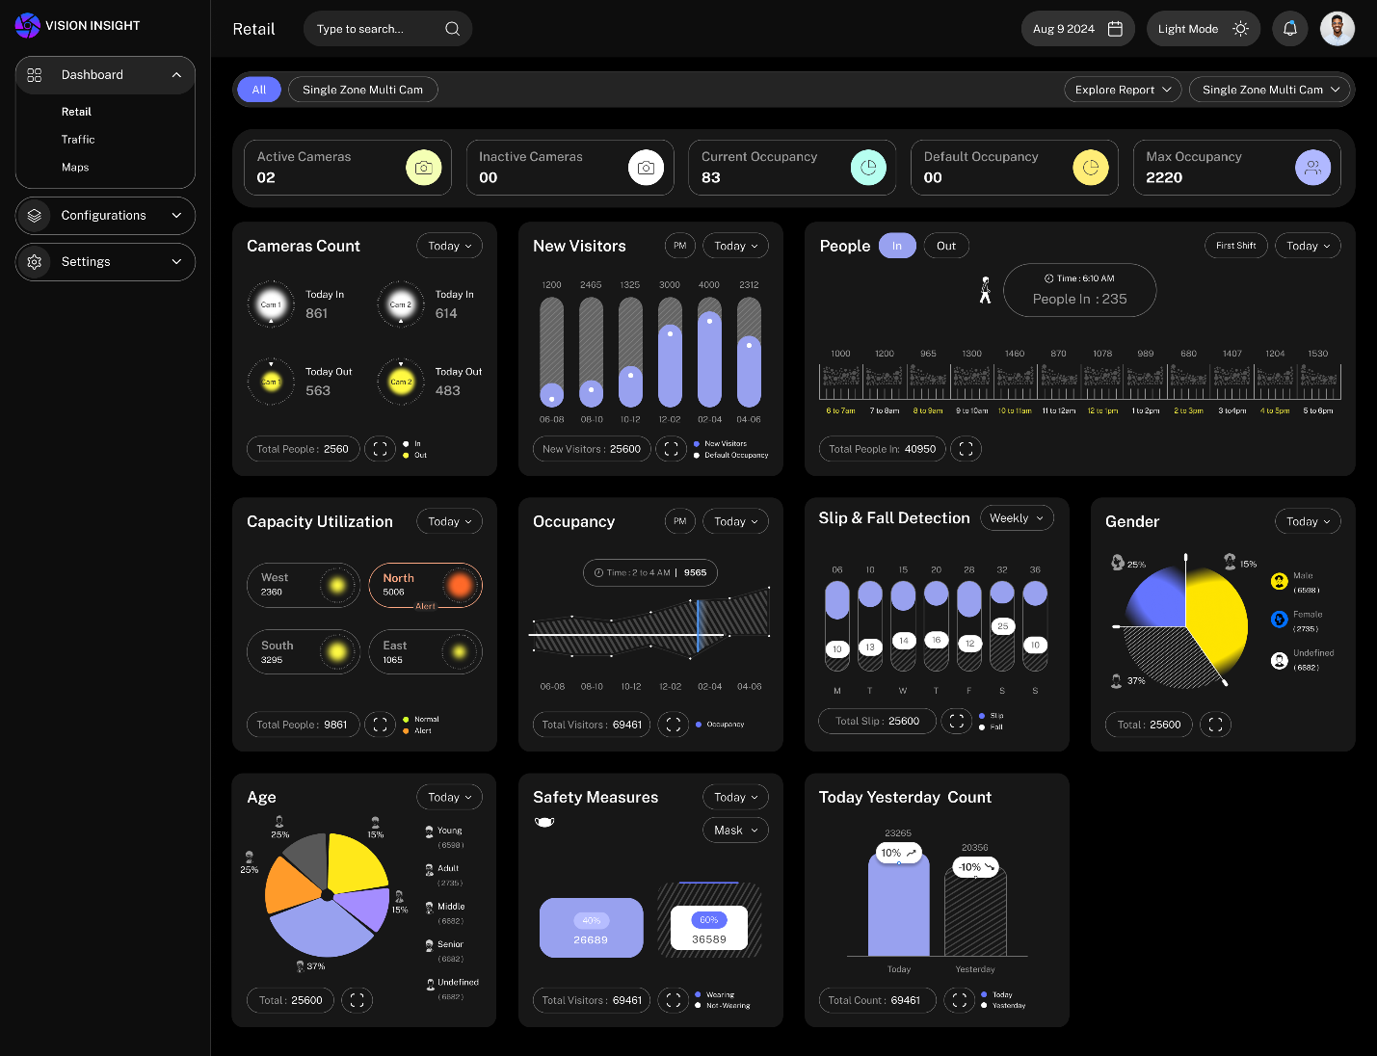

**#3. Traffic:**

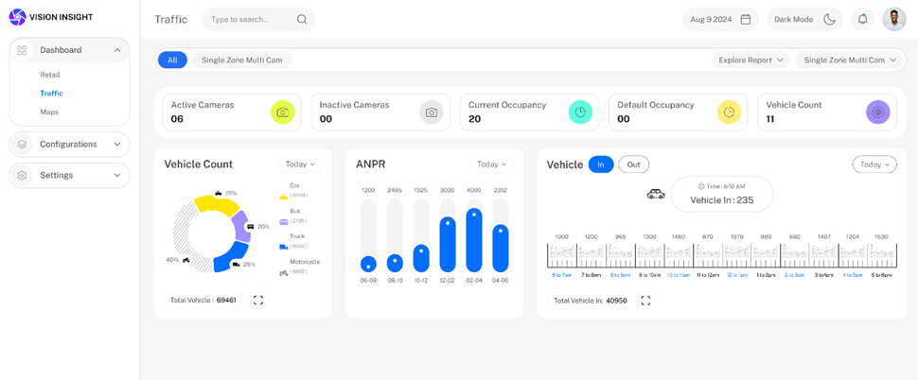

**#4. Popup View (To see the specific Cameras Count):**

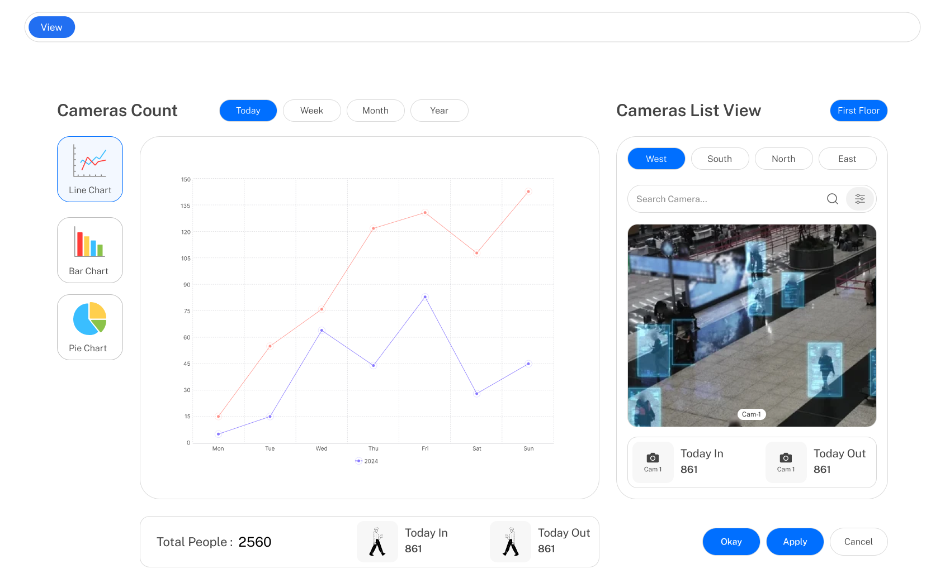

## Assumptions

### General

* This estimation is based on the requirements shared and discussed with the client.
* Any interfacing requirement not discussed or understood from the discussed requirements is not part of this current document, and such requirements will be handled and addressed during the offsite requirement gathering process (SRS).
* The feature list is prepared based on the client's discussion; hence, changes may be made after completing the requirements study, which may require discussions under the change management process.
* SPEC will have no liability for hardware failure deployed when running the proposed solution. Hence, the Client should only take up relevant issues with the provider for the respective system.
* Any delay in the project schedule due to decision-making, data gathering, or approvals from the client side should be handled at the client's side. SPEC won’t be responsible for adding more resources for early completion in such scenarios.
* The warranty period will automatically start ten days after the UAT rollout.
* The warranty period will **be 3 months.**
* After warranty completion, extra charges will be charged for knowledge transfer or documentation for/to another vendor (as efforts vary depending on third-party capability).
* Server hosting fees, App Store (development account) fees, SMS Gateway fees, and any third-party API/SDK fees are not included in the development cost.
* The client will own the developed product and source code submitted after the final milestone payment.
* A delay during any phase of the project by the customer will not be considered a delay by SPEC, and any payment milestone will not be delayed due to it.
* Any delay in providing feedback or required dependency for more than two weeks will be escalated by SPEC.
* The Web Application will work on desktop and laptop screens; it is not mobile & tablet responsive. It will work on the latest versions of Google Chrome, Mozilla Firefox, and Safari.

### Project Specified

* In the initial phase, the web application and admin panel will only support English.
* UAT will be done entirely by the client, so the proposal does not include an estimation for QA testing.

## Technology Stack

### Technology Stack for Web Application Development

* Front-End development: ReactJS
* Back-End development: .Net Core
* Database: MongoDB

# Project Timeline

|  |  |  |
| --- | --- | --- |
| Sr. No. | Description | Timeline |
| 1 | Wireframe & SRS | 4 Weeks |
| 2 | Web Application Development | 18-20 Weeks* |

*The development timeline will start after the finalization of Wireframe & SRS.

* The timeline for approx. **Eighteen to Twenty weeks** of development mentioned above is purely considered for development.
* It is understood that since the client is responsible for QA testing and providing UAT sign-off, timely testing and UAT sign-off are imperative. Otherwise, the same might result in a delay in the project's delivery.

# Commercials

## Total Effort and Cost Estimation

|  |  |  |
| --- | --- | --- |
| Sr. No. | Description | Amount (USD) |
| 1 | Web Application Design and Development | $43,100 |

## Payment Milestones

|  |  |  |  |
| --- | --- | --- | --- |
| Sr. No. | Description | Amount (in %) | Amount (USD) |
| 1 | Milestone #1: Upfront Payment | 20% | $8620 |
| 2 | Milestone #2:   * After delivering the Wireframe and SRS | 10% | $4310 |
| 3 | Milestone #3:   * Camera API Understanding and Integration * Admin Web App (Partial) * User Login * User Management * Camera Management * Site and Zone Management * Data Ingestion (Partial) | 30% | $12,930 |
| 4 | Milestone #4:   * Admin Web App (Customer Licensing details, generating license) * Data Ingestion (Remaining) * Dashboard Widgets (Camera/Site/People/Retail/AI Box) * Dashboard Reports Filtering * Settings (Upload Customer Logo) * Map Integration | 20% | $8620 |
| 5 | Milestone #5:   * People/Vehicle/Factory Dashboard Widgets * Export Reports to PDF/excel/csv. * Create an Installable Package * Settings (License Management) * Configuration (Backup and Restore) * Alexa Integration * Solar Power & Battery Utilization & other 7 Key features. | 20% | $8620 |

## Miscellaneous Charges

|  |  |  |  |
| --- | --- | --- | --- |
| Sr. No. | Description | Unit | Amount (USD) |
| 1 | Change Requests Charges | Hourly | $18 |
| 2 | AMC Contract Charges – for a minimum of 40 Hours / Month, along with the flexibility to utilize the hours within a year from the commencement date. | Yearly | $18 |

## Payment Terms & Conditions

1. The above charges exclude taxes or transfer fees.
2. AMC will be imposed after the completion of the free warranty period of 3 months.
3. Invoice for AMC will be raised quarterly at the start of every quarter**.**
4. Hanwha and SPEC agree on cost escalation for next year (including this renewal) with 12%  
   Across all the commercials without the need for any negotiation for the upcoming renewal.
5. The Annual Maintenance and Support cost is subject to rise (cost escalation) by 12% annually.  
   Additionally, 12% of the total paid changes implemented in subsequent years will be added to the last enhanced contract value. An annual meeting/discussion to review the cost increase applicable other than those mentioned herein will be set up.
6. This would cover standard maintenance support as mentioned above. This support will be limited to minor changes like label/caption/title changes, changes in the message or alert text, and changes in the order of placing controls on the forms/screens. In contrast, any new feature, change in functionality, the addition of controls/components/screens, workflow/ business logic change, etc., will be considered a Change request and will follow the change management process.
7. Charges provided for CR are subject to rise by 12% annually.
8. All charges mentioned above are applicable till November 2025.
9. This proposal will be valid for 25 days from submission.
10. Per the details below, payment should be made via bank/wire transfer within 5 Business Days of invoice submission. The client will bear the charges.

|  |  |
| --- | --- |
| Remittance Details | |
| Name of Nostro A/C | Bank Of Baroda New York |
| Address | 1, Park Avenue, New York |
| Account Number | 93010200000070 |
| Swift BIC Code | BARBUS33 |
| UID | 137944 |
| FED ABA No. | 026005322 |
| For Further Credit To: | |
| Name of Bank | Bank of Baroda |
| Account Number | 77970200001197 |
| Beneficiary Name | SPEC INDIA |
| Swift Code | BARBINBBREL |
| Account with | Bank of Baroda, Relief Road, Ahmedabad (INDIA) |

1. All prices above only cover offsite charges.
2. The client will bear the cost of any third-party software licensing, APIs, or hardware related to implementing the solution and licensed images.
3. During warranty support, the SPEC team will be responsible for resolving all the bugs. Any changes or enhancements to features/design will follow the change management process.
4. Response hours for any case will be per SLA defined and finalized during project kick-off.
5. Offsite support during warranty and AMC will be limited to weekdays from Monday to Friday from 10:00 AM to 7:00 PM (including a one-hour break) through SPEC’s helpdesk system, except for SPEC holidays. The client must raise a ticket and call the assigned number for critical support.
6. The project scope and warranty will not cover the development of any requirement/feature that is not part of the SRS document finally signed off. Any customization/change request will be chargeable.
7. The escalation matrix for support will be shared with the core team of Clients at the project kick-off, with up to three (three) levels of hierarchy.
8. The source code will be handed over only after the complete payment.
9. No Hire: During the term of this Agreement, and for twenty-four (24) months from the date of the termination or expiration of this Agreement, CLIENT will not, either individually or on behalf of, or through any third party/affiliates/companies/partners, solicit, entice, persuade, or attempt to solicit, entice, or persuade, any employees of or consultants of SPEC to leave the employment of SPEC or consultants who have gone for any reason, or hire or attempt to hire any such employees or consultants directly or indirectly through company contracts or hourly consulting onshore or off-shore. If SPEC notices any such incident, SPEC reserves the right to take necessary actions in the best interests of the SPEC organization.
10. Force Majeure: In the unforeseen event that SPEC is unable to perform its obligations under the terms of this Agreement because of acts of God, epidemic/pandemic, lockdowns, strikes, equipment or transmission failure, or damage reasonably beyond its control, or other causes reasonably beyond its control, SPEC shall not be liable for any costs or damages due to delay or nonperformance under the terms of this Agreement.
11. Due to uncertain times and the situation at hand due to COVID-19, we won’t be able to provide immediate replacements for resources if the resource working for the client tests COVID+, as the duration of treatment is very uncertain and varies from person to person. At best, we would be very transparent with you on the existing situation and the best way to move forward on a case-to-case basis.
12. Production/Live Server Access: The customer is highly recommended to manage the production system deployment/maintenance activities. SPEC can provide read-only access to the production environment for validation if required. Suppose a customer cannot manage the production system deployment/maintenance. In that case, the customer can provide access to SPEC for the production environment while keeping all the security risks in mind. SPEC would not be held accountable for any damage to customer business due to loss of data/security incidents/data breaches in the production environment. Under no circumstances will SPEC be responsible for any data lost, corrupted, or rendered unreadable due to (i) communication and transmission errors or related failures, (ii) equipment failures (including but not limited to silent hardware corruption-related issues), or (iii) failure to backup or secure data from portions of the production Environment.
13. During the term of this Contract, the Client can’t audit SPEC accounts/books for any purpose.
14. During this agreement, SPEC is not responsible for any Cyber-attack on the client's UAT or Production Environment.
15. SPEC is not liable for procuring cybersecurity liability for any ongoing project during the term of this contract.
16. SPEC can’t accept any gift/promotions for any particular/ Individual resource of SPEC working on the Project.
17. In the event of termination of the development and AMC services, SPEC is not liable to transfer them to a third party.
18. If the development and AMC services are terminated, SPEC will provide knowledge transfer to the client team only. This will be done twice the per-day rates for the days required in advance.
19. SPEC shall not be responsible for providing any training, demos, or understanding sessions for Source Code to a third Party. If knowledge transfer is to be given to any third party, the total cost will be determined at the time of handover to the third party. The payment for the same must be made 100% in advance. All other terms and conditions remain the same.
20. If the Client wants thorough documentation of the Client’s application, the charges will be determined at that time. The payment for the same must be made 100% in advance. All other terms and conditions remain the same.
21. Once the PO is awarded, the total value cannot be reduced during the contract duration.
22. SPEC will charge 2X for a full day (8 hours) for any holiday work.
23. In the event of project closure, all the outstanding payments must be made to SPEC before the last working day of the Project.
24. SPEC reserves the right to hold the source code in case of non-receipt of outstanding payment until the outstanding payment is cleared.
25. All payment received under this Agreement and the Attempt Agreement is non-refundable.

# Execution Methodology For AMC

* 1. All tickets (requests for bug support/changes) will be logged in SPEC’s Helpdesk management

system along with a priority by the client.

* 1. The support team shall provide All mandatory ticket analysis informationMax.

Information like screenshots, logs from the database, etc. The objective of detailed problem communication is to minimize iterations for simulation by the Support team.

* 1. For any change request, the client must post requirements via email only, and no verbal

communication will be considered. The client must also create a Change request in the SPEC RED System.

* 1. For any support-related request/bug, the client needs to use the SPEC RED System, which is our

system designed especially for AMC Support projects.

* 1. SPEC will provide 24/7 support for all Critical priority tickets. However, if the resource allocated to the project is on leave due to personal or festival reasons, the clause won’t apply on that day.
  2. For all Critical priority errors, an intimation via phone call in English or Hindi to SPEC

support personnel will be required to update about Critical errors being encountered. SPEC shall share relevant contact details. A ticket must also be reported in the SPEC Support Helpdesk System ‘RED,’ access to which has already been given to the Client’s project team.

* 1. Change tickets will be estimated and approved before being implemented.
  2. Changes will not be part of critical support.
  3. All critical and significant errors will be managed by providing a patch, and all other tickets and change tickets will follow a standard release protocol.
  4. Release planning will be done along with the authorized/assigned person of the CLIENT.
  5. Support team knowledge management will be part of the scope, ensuring the availability of primary and backup resources.
  6. Offsite support during warranty and AMC will be limited on weekdays from Monday to Friday from 10 AM to 7 PM through SPEC’s helpdesk system. SPEC holidays shared below in the document will be followed.
  7. The entire AMC will be executed from offsite, i.e., the SPEC Office in Ahmedabad, and does not include travel to the Client Office.

# List of Assumptions / Exclusions & Dependencies

1. The scope does not include any issue requiring the product vendor (Hardware / Operating System, third-party components).
2. Changes will not be part of critical support.
3. Major Changes will not be part of the current scope and will be considered as a separate project.
4. Server hosting fees, license costs, and any other third-party API/SDK fees are not part of the development cost and do not fall under the role and responsibilities of SPEC. Hence, the client must manage the ownership and procurement of these fees.
5. SPEC will have no liability for hardware failure deployed to run the proposed solution, and hence, the Client should take up relevant issues with the provider only for the respective system.
6. SPEC will not be responsible for any Server Setup/configuration on the client’s UAT or Production Environment, whether on-premise/GCP or any other cloud.
7. SPEC will not be responsible for any Database Upgrade of the PostgreSQL Database in GCP Cloud or any other Maintenance Upgrade.
8. SPEC will not be responsible for monitoring GCP Cloud after the database's migration from Oracle to PostgreSQL in GCP Cloud.
9. SPEC will not be responsible for Oracle or PostgreSQL Database administration.
10. The client will be solely responsible for the Oracle or PostgreSQL Database administration activities.
11. Once the application is live in Production, the DB Maintenance Plan must be configured by the client.
12. SPEC will not be responsible for any Point-in-Time Database Recovery/DR Drill/Oracle/PostgreSQL—DB Server Maintenance tasks, etc.
13. SPEC will not be held responsible for any table or database corruption in PostgreSQL on GCP cloud post migration, which has occurred due to any unprecedented event.
14. The total AMC amount has been derived using the application's base cost, the CRs implemented, and the inflation cost with a discount offered to the client.
15. A portion of Changes Implemented as part of the current year AMC – 2024-25, which has provided

additional features & extended functionality for the client application need to be accounted for additional support efforts and enhancements.

1. The client cannot present a gift to any particular or a single SPEC resource working on the client Project.
2. The rotation of resources allocated in the project will be at the sole discretion of SPEC INDIA.

# Project Approach and Methodology (Standard)

## Project Approach

The proposed approach for executing this project is the Waterfall approach, in which requirements will be gathered, analyzed, and baselined to form the system's scope.

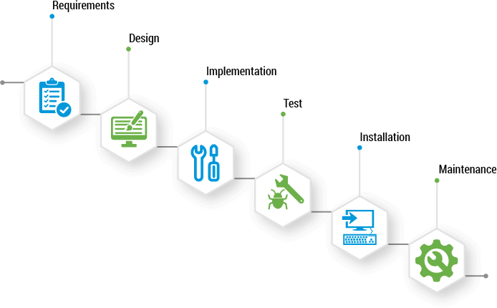

### Execution Methodology

#### Project Initiation

During this phase, both Client and SPEC shall do the following:

* Prepare Project Charter
* Core Team formation both at Client and SPEC
* Single Point of Contact identification at Client
* Project Kick-Off
* Laying down Communication Plan
* Laying down Escalation Plan
* High-Level Project Plan
* Risk Assessment and Mitigation Strategy

#### UAT (User Acceptance Testing)

UAT will be done offsite and involve Core Project Team members from the Client and SPEC. The client is assumed to have completed the required hardware/software installation before the start of the UAT. It is recommended that a separate Test and Production environment be created.

In this phase, SPEC will train the UAT team to carry out the UAT. The core team at the client's end will carry out the testing based on the test cases provided by SPEC and those derived by the Client from real-life scenarios. SPEC will capture and resolve any errors encountered. The UAT offsite support will last five business days. Any delays in starting/completing UAT within the specified period may involve cost implications.

There will be a formal sign-off for the UAT. Any improvements/changes to the system that are arrived at in this phase will be documented and will follow the change management process.

#### System Deployment and User Training

SPEC will carry out training on the system offsite. The training will be done using the “Train the Trainer” concept for two business days, during which the client's trained employees can later train the other business users. Training will be executed in parallel to the UAT phase. The client will provide the necessary infrastructure for training. If more training is required, this would be charged extra on a person-day basis.

#### Warranty Support

Soon after the UAT sign-off, warranty support for the project will begin. If the system is not deployed within a week of the UAT release, warranty support will be deemed to start. This support will be given from off-site and will cover only bug support and fixes. Any changes/enhancements requested during this phase will follow the change management process.

#### Project Closure

After completing the warranty and AMC (if opted for), the project will be deemed closed with a formal sign-off from the client's Project Core Team and Steering Team, and the source code will be handed over. Source code can also be handed over after the final payment release and go live.

## Change Management Process and Bug Support

### Bug Support

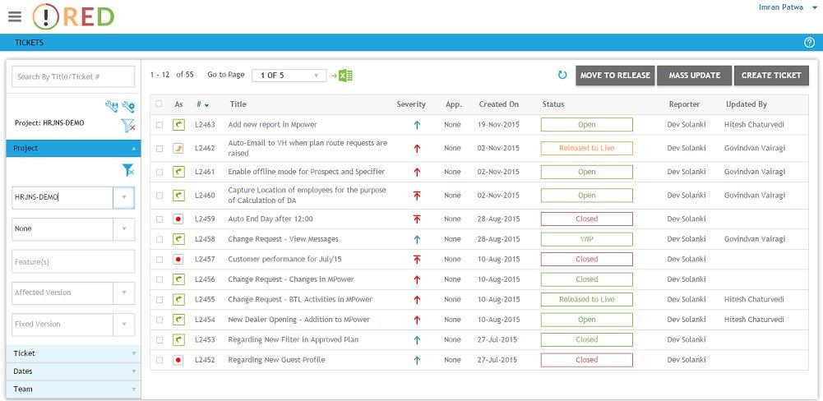

SPEC has an online ticketing system and proposes using it to capture all the errors/bugs encountered during the solution's deployment. This will help track the reported issues and manage tickets properly.

**Definition**

* Any existing functionality that is not working as required should be classified as an incidence/error

### Change Management Process

For managing change requests, SPEC proposes to utilize SPEC’s online ticketing system post-deployment

**Definition of Change**

* Any change/enhancement/optimization that is required in the current features of the application requirement
* Any new functionality, enhancement, or modifications that need to be incorporated into the system

1. The client must first enter all issues/changes in SPEC’s online helpdesk system, RED.
2. Changes to be included will be identified jointly and approved by the Client’s core team in consultation with the SPEC project team.
3. These new requirements will be estimated based on the required efforts and evaluated for cost and schedule impacts.
4. After approval, the SPEC team will start working on the new change after receiving an official confirmation of cost and time.

## Review Process

Status reports would be provided at agreed-upon frequency, indicating the project's progress against milestones as per the Communication Plan.

The project managers from SPEC and the Client would hold status meetings every fortnight or at the agreed-upon frequency per the Communication Plan.

The steering committee's review meetings would be held monthly or at the agreed frequency. These forums would review risks, Issues, and Concerns affecting the project in terms of schedule, budget, and quality. Any deviations from the plan would be escalated to the steering committee.

## Execution Environments

SPEC proposes to have the following various execution environments. This primarily means that there will be four different environments for the project execution:

* Development Environment (at SPEC site)
* Testing Environment (at SPEC site)
* Production / Release Environment (At Client site)

## Escalation Matrix

|  |  |  |  |
| --- | --- | --- | --- |
| Company | Contact Point | Role | Mode of Contact |
| SPEC | Project Manager | 1st level of escalation and primary contact for technical issues assistance | Email & Phone |
| SPEC | Practice Head | 2nd level for issues and escalation | Email & Phone |
| SPEC | Group Practice Head | 3rd level for escalation | Email & Phone |

**Note:** Details of the contact points will be shared just before the project kick-off and upon awarding the project

# Project Management Methodology at SPEC (Standard)

SPEC has formal Project Management Practices and a well-defined Project Execution Methodology implemented in the ISO processes. Below is a snapshot of this methodology for a quick overview. Activities will vary on a project-to-project basis.

|  |  |  |
| --- | --- | --- |
| Sr. No. | Phase | Activity |
|  | Project Initiation | * Project Charter * High-Level Project Plan * Risk Assessment * Project Team Formation * Project Kick-Off |
|  | Project Planning | * Detailed Project Plan * Communication Plan * Documentation Plan * Test Plan * Configuration Management Plan * Tracking Plan * Risk Register |
|  | Project Execution & Control | * System Requirements Specifications * Technical Architecture * Technical Design * Test Results * Development and Quality Assurance * Release Notes * Change Control * Cost & Schedule Control * Status Reporting |
|  | Project Closure | * User Training / Knowledge Transfer * User Acceptance Testing * Deployment & Solution Delivery * Warranty & Support * Post Implementation Support & AMC (upon PO) * Project Signoff & Source Code handover |

## Testing and Quality Assurance at SPEC

Over the years, we have evolved our software development and support process, quality, and project management practices to align with the best in the industry. Our ISO 9001:2015 certification accredits our commitment to quality initiatives.

To ensure commitment to quality, SPEC has an independent V & V department that provides high-quality deliverables to customers. The following activities are carried out as part of Quality Assurance practice:

* Quality standards like GUI standards, coding standards, modular structure, etc. must be followed.
* Peer review of code at random to ensure standards are strictly adhered to.
* Document review & approval before delivery of any documentation.
* Fair mix of automated and manual testing
* Rigorous testing with live data provided by the client in our test environment
  + Unit testing, Integration testing
  + Performance testing (optional at added cost)
  + Load testing (optional at added cost)
  + Regression testing

# Project Deliverables

* System Requirement Specification
* UI Design
* Source code.

# Responsibilities of Client and SPEC (Standard)

|  |  |  |
| --- | --- | --- |
| Sr. No | Role | Responsibility |
|  | Client Team | * Form a Project Core team and assign a Single Point of Contact * Single Point of Contact to keep control over the project proceedings. * Take part in daily/weekly / fortnightly review meetings as laid out in the communication plan * Scope management * Provide timely approvals wherever required * Manage schedule variance * Manage & mitigate Risks and escalate issues as required * Project Review * Enter bugs and changes as tickets in the Helpdesk System |
|  | SPEC Team | * Resource availability - Availability of engineers and systems and identify and communicate single Point of Contact as Project manager * Scope Management * Form a Steering Committee to keep control over the project proceedings. * Take part in daily/weekly / fortnightly review meetings as laid out in the communication plan * Manage and Mitigate Risks * Project Review * Status Reporting * Timely escalations * Configuration Management * Requirement gathering and analysis * System development * UAT & Training * Implementation support * Warranty Support * Annual Maintenance and support (upon PO) |

# Project Team Organization (Standard)

The Project Team at SPEC comprises the Project Manager, Business Analyst, Technical Architect, Design Team, Developer Team, and Testing team under a shared resource model.

* The Technical Architect would be responsible for the technical architecture, implementation, and performance.
* The Project Manager would be responsible for project management, budget, schedule and quality control, delivery, and status reporting.
* The Business Analyst would be responsible for understanding and translating the requirements into a detailed design for actual implementation, ensuring the end deliverable meets business requirements, and completing the required documentation. This resource will be techno-functional.
* The developer would be responsible for the actual development.
* The testing team would validate the application based on test cases and prepare the test report.
* Customer would be responsible for providing requirements, clarifying queries, and user acceptance.

# Risk identification and mitigation plan (Standard)

Below are some of the high-risk ones identified.

|  |  |  |
| --- | --- | --- |
| Sr. No | Risk Description | Mitigation Plan |
| 1 | Delay in receiving requirements from end-users. | Plan the requirement gathering phase early so users can be prepared with their requirements.  Form a Project Core team of business users and assign a single POC for better and timelier requirement gathering. |
| 2 | Changes in the scope of work during the project life cycle (specifically in the requirement phase, UAT) | Planned development of low-priority changes post-go-live during the support period as a separate release/patch and as described in change management.  For high-priority changes, SPEC will keep a buffer resource to handle the development of such changes raised during the requirement phase to meet the project's final timeline.  Plan prototypes early in the project life cycle to avoid change during the later stage of the project. |
| 3 | Changes in Third-Party API Used in the project.  Error/Glitches in the system due to changes  Added efforts to solve & integrate new/updated APIs | Usually, this scenario is rare, but it depends on the platform. If any third-party API releases a newer version or the used version gets deprecated by the provider, we will analyze the efforts to resolve this issue and get approval before implementation. |
| 4 | OS version updates  Errors/Glitches in the App due to the new OS rollout  Some features may stop working due to deprecated functions in the new OS  Discontinuation of feature/function in new OS based on a deprecated code library | Android and iOS release OS version updates every year, so some updates are bound to be required to resolve glitches.  Usually, new OS versions are backward compatible, but if the OEM is conducting a major overhaul, more effort is needed to replace the deprecated libraries.  To avoid such incidents, Beta/Developer versions of the new OS versions (if available) can be crosschecked to identify code/library deprecation at the preliminary phase and avoid rework on the same after the official roll-out. |
| 5 | Unexplored Devices  Numerous devices are available in the market, especially in Android and IoT, and behavior on unexplored devices (non-branded OEM) may vary. | In such cases, the exact devices used in production should be available during testing.  For Android apps, practically testing all available devices in the market is impossible, so we need to identify the resolution size and OS versions we need to support. |
| 6 | Internet Speed  Internet bandwidth and speed vary in geographical regions, and the app's performance highly depends on them. | The expected internet infrastructure should be known to avoid expectation mismatch due to such issues. |
| 7 | Availability of Signal Strength  The signal strength of the Internet, Bluetooth, GPS, WiFi, and WiFi Direct varies depending on infrastructure, device type, environment, inferences, etc. | The behavior observed during the development and testing environment may not match precisely during the production roll-out.  A pilot run before production in such cases is the best remedy. |
| 8 | Hardware / Device Limitations  Gyroscope/Accelerometer/GPS/Fingerprint/Camera performance varies drastically depending on the hardware chip used in Mobile devices. | The targeted mobile devices should be known to avoid performance mismatch during production rollout.  (e.g., counting steps/running/walking apps) |
| 9 | Changes in Third-Party Devices (e.g., Bluetooth printer, Beacons, Barcode reader, etc.)  Integration of third-party devices depends on the availability of API and compatibility with the selected OS. | If OEM pushes a newer device or integration API version, it may not be compatible with the existing developed application/system. We must identify the efforts to upgrade the system and get pre-approved before implementation. |

# SPEC Holiday Calendar 2025

|  |  |  |  |
| --- | --- | --- | --- |
| **SPEC LIST OF TENTATIVE HOLIDAYS 2025** | | | |
| **No** | **Date** | **Day** | **Holiday** |
| **1** | 14-Jan | Tuesday | Makar Sankranti |
| **2** | 26-Feb | Wednesday | Maha Shivaratri |
| **3** | 14-Mar | Friday | Holi |
| **4** | 15-Aug | Friday | Independence Day |
| **5** | 2-Oct | Thursday | Mahatma Gandhi Jayanti |
| **6** | 20-Oct | Monday | Kali Chaudas/ Diwali |
| **7** | 21-Oct | Tuesday | Padtar Diwas |
| **8** | 22-Oct | Wednesday | New Year |
| **9** | 23-Oct | Thursday | Bhai Dooj |
| **10** | 24-Oct | Friday | Holiday |

# Signatures

|  |  |
| --- | --- |
| For SPEC INDIA | For IVTECH COMPUTER SYSTEMS LLC |
| Date & Signature: | **Date & Signature:** |
| Signatory Name: Milind Shroff - CEO  Address: ‘SPEC House’ Parth Complex, Swastik Cross Roads, Navrangpura, Ahmedabad – 380 009 | **Signatory Name:**  **Address:** |